Introduction to Social Psychology
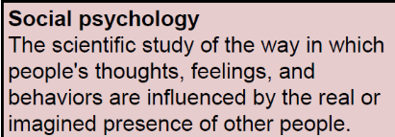
What is Social Psychology?

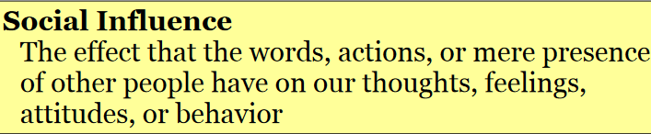
- Social psychologists are interested in understanding how and why the social environment shapes the behaviors, thoughts and feelings of the individual.
  - At the very heart of social psychology is the phenomenon of social influence: We are all influenced by other people.
- We are governed by the imaginary approval or disapproval of our parents, friends, and teachers and by how we expect others to react to us.
- Sometimes these influences conflict with one another, and social psychologists are especially interested in what happens in the mind of an individual when they do.
Social Psychology, Science, and Common Sense
- As people, we aim to answers to a wide array of important questions:
  - What are the factors that cause aggression?
  - How might we reduce prejudice?
  - What variables cause two people to like or love each other?
  - Why do certain kinds of political advertisements work better than others?
  - Why do I behave, feel, think in a way that I do?
- Social psychology versus philosophy
  - Philosophy
    - Throughout history, philosophy has been a major source of insight about human nature.
    - The creativity and analytical thinking of philosophers are a major part of the foundation of contemporary psychology.
  - But what happens when philosophers disagree?
    - Social psychologists address many of the same questions that philosophers address, but we attempt to answer them scientifically.
- Social psychology versus common sense
  - Common sense = Folk Wisdom (Another approach to get answers for the questions)
    - Although a great deal can be learned from “common sense” knowledge, there is at least one problem with relying entirely on such sources:
    - They frequently disagree with one another, and there is no easy way of determining which of them is correct.
      - Are we to believe that “out of sight is out of mind” or that “absence makes the heart grow fonder”?
      - Which is true, that “haste makes waste” or that “he who hesitates is lost”?
    - Part of the job of the social psychologist is to do the research that specifies the conditions under which one or another is most likely to take place.
- Social psychology is an experimentally based science.
  - As scientists, our goal is to find objective answers to a wide array of important questions
  - Social psychology, like any science, involves:
    - Description - careful and reliable observation
    - Explanation - development of theories that connect and organize observations
- Journalists, Politicians, Philosophers are also interested in social influence
- Social Psychologists differ by:
  - Developing explanations by using the scientific method (e.g., experiments)
  - Considering many variables at the same time
How is Social Psychology Different From Its Closest Cousins
- Social psychology is related to other disciplines in the physical and social sciences, including biology, neuroscience, sociology, economics, and political science.
- Each discipline examines the determinants of human behavior, but the difference between social psychology and other social sciences in level of analysis:
  - For the social psychologist, the level of analysis is the individual in the context of a social situation.
- Biology— Neuroscience/ Evolutionary theory
  - For biologists and neuroscientists, the level of analysis might be genes, hormones, or physiological processes in the brain.
  - Evolutionary Psychology explain social behavior in terms of genetic factors that have evolved over time according to the principles of natural selection social behaviors that are prevalent today, such as aggression and helping behavior, are a result, at least in part, of adaptations to environments in our distant past.
- Sociology
  - Sociologists are also interested in social phenomena
  - Social Psychologists differ by:
    - Taking the individual in the context of a social situation as the unit of analysis; Sociologists study the entire group/ institution
    - “Sociology is the structure of the wall, Social Psychology is the interactions between the bricks”
  - Sociologists study the group or institution
  - Social psychologists study the influence of those groups and institutions on individual behavior.
- Personality Psychology
  - Personality psychologists explain the behavior in terms of the person's individual traits.
  - While social psychologists would agree that personalities do vary, they explain social behavior in terms of the power of the social situation (as it is construed by the individual) to shape how one acts.)
  - Personality psychologists study qualities of the individual
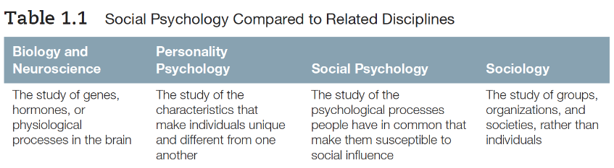
  - Social psychologists study the powerful role of social influence on how all of us behave.

Social psychology is mainly interested in two things:
- the power of the situation (aggressive person vs. aggressive people in certain conditions?)
- the power of social interpretation (construal)
The Power of the Situation
- “How come people act differently in different environments?”
  - Crosswalk at campus vs. Crosswalk at the other parts of the city
  - Hitchhiking at METU campus vs. Hitchhiking at the other parts of the city
- We tend to think that the way someone behaves is caused by their personality and not the situation they are in.
- We underestimate the power of the situation.
  - E.g., Someone illegally overtook you in traffic.
  - What do you say? “What a lousy driver!” or “They must be in a hurry”
- When trying to convince people that their behavior is greatly influenced by the social environment, the social psychologist is up against a barrier:
  - All of us tend to explain people’s behavior in terms of their personalities.
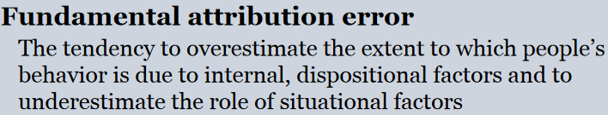
  - We are more likely to put the blame on the person rather than the situation

Underestimating the Power of Social Influence
- When we underestimate the power of social influence, we gain a feeling of false security.
  - Gives the rest of us the feeling that we could never engage in the “bad” behavior shown by others (e.g., forgetting the date, appointment)
- By failing to fully appreciate the power of the situation, we tend to:
  - Oversimplify complex situations which decreases our understanding of true causes which might increases our personal vulnerability to possibly destructive social influence
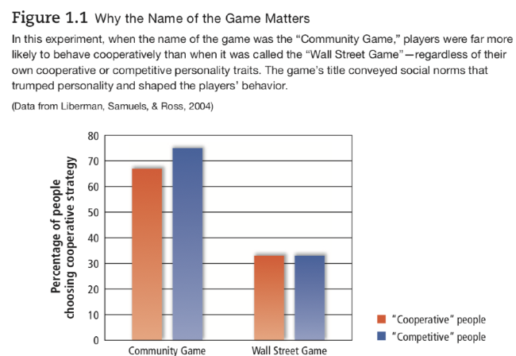
  - Blame the victim when people are overpowered by social forces.

- Aspects of the social situation that may seem minor can have powerful effects, overwhelming the differences in people’s personalities.

- Personality differences do exist and frequently are of great importance

  - But social and environmental situations can be so powerful that they have dramatic effects on almost everyone.

The Importance of Construal: The Power of Social Interpretation
- What exactly do we mean by the social situation?
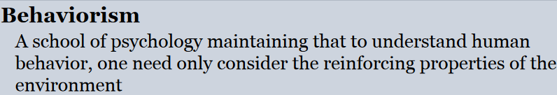
  - One strategy for defining it would be to specify the objective properties of the situation and then document the behaviors that follow from these objective properties.

The Subjectivity of Social Situation
- Behaviorists chose not to deal with cognition, thinking, and feeling because they considered these concepts too vague and mentalistic and not sufficiently anchored to observable behavior
  - Therefore provided inadequate explanation for a complete understanding of the social world.
- We need to look at the situation from the viewpoint of the people in it, to see how they construe the world.
- It is not just the objective situation itself, but how you perceive it is also very important!
- Construal: How people perceive, comprehend, and interpret the social world and the behaviors of others.
- To understand social influence it is more important to understand how people perceive and interpret the social world than it is to understand that world objectively.
- Human beings are sense making creatures, constantly interpreting things.
- How humans will behave in a given situation is not determined by the objective conditions of a situation but rather how they perceive it (construal)
- The emphasis on construal, the way people interpret the social situation, has its roots in an approach called Gestalt Psychology.
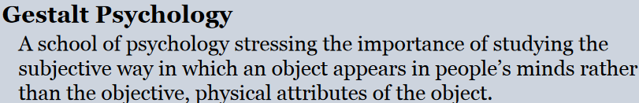

  - Kurt Lewin generally considered as the founder of modern experimental social psychology
  - Lewin took Gestalt principles beyond the perception of objects to social perception.
  - Lewin was the first scientist to stress the importance of taking the perspective of the people in any social situation to see how they construe this social environment.
  - Naïve Realism The conviction that we perceive things “as they really are,” underestimating how much we are interpreting or “spinning” what we see
  - Naïve Realism The conviction that we perceive things “as they really are,” underestimating how much we are interpreting or “spinning” what we see
Where Construals Come From: Basic Human Motives
- Construals are mainly shaped by two basic human motives:
  - The Need to Be Accurate (The Social Cognition Approach)
  - The Need to Feel Good About Ourselves (The Self-Esteem Approach)
- But these motives can sometimes be at conflict, the need to feel good about our decisions can fly in the face of the need to be accurate.
The Self-Esteem Approach: The Need to Feel Good About Ourselves
- Most people have a strong need to maintain reasonably high self-esteem
- People might distort the reality in order to feel good about themselves instead of representing the reality accurately.
- Self-Esteem: People’s evaluations of their own self-worth (the extent to which they view themselves as good, competent, and decent)
Suffering and self-justification:
- Admitting major deficiencies in ourselves is very difficult, even when the cost is seeing the world inaccurately.
- People can put slightly different spin on the existing facts, one that puts us in the best possible light.
- Divorce:
  - Truth: husband jealousy and possessiveness
  - Husband: ex-wife was not responsive enough to his needs
  - Self-esteem of the husband is maintained yet learning from experience becomes unlikely
- Why would hazing cause someone to like his fraternity?
- Experiments demonstrated that the more unpleasant the procedure the participants underwent to get into a group, the better they liked the group.
- The important points to remember here are:
  - (1) That human beings are motivated to maintain a positive picture of themselves, in part by justifying their past behavior, and
  - (2) That under certain specifiable conditions, this leads them to do things that at first glance might seem surprising or paradoxical.
- For example, they might prefer people and things for whom they have suffered to people and things they associate with ease and pleasure.

The Social Cognition Approach: The Need to Be Accurate
- Social Cognition: How people think about themselves and the social world (how people select, interpret, remember, and use social information to make judgments and decisions)
  - Individuals are viewed as trying to gain accurate understandings so that they can make effective judgments and decisions that range from what to eat to whom they will marry.
  - In actuality, individuals typically act on the basis of incomplete and inaccurately interpreted information.
Most people try to have an accurate view of the world but often do not have enough information to make accurate judgments.

